 | 7.1.41 Editors - 3D Viewport - Header - Hair Curve - Edit mode – Control Point menu
Table of content
Edit mode – Control Points menu 1
Extrude Curve and Move 1
Set Handle Type 1
Free 1
Auto 1
Vector 1
Align 1
Last Operator Set Handle Type 2
Type 2

Edit mode – Control Points menu
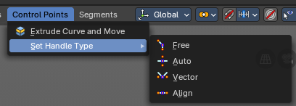

Extrude Curve and Move
Extrudes the selected hair curve points, and moves it.

Set Handle Type

Handles defines the type of handle for the knots of the curve. You have the choice between Auto, Vector, Align and Free.


Free
Set Handle type to Free.

Auto
Auto aligns the handles automatically.

Vector
Set Handle type to Vector.

Align
Set Handle type to Align.


Last Operator Set Handle Type

Type
Type is a drop-down box where you can set the handle type. You have the choice between Auto, Vector, Align, Free. And the fifth possibility toggles between Free and Align.

